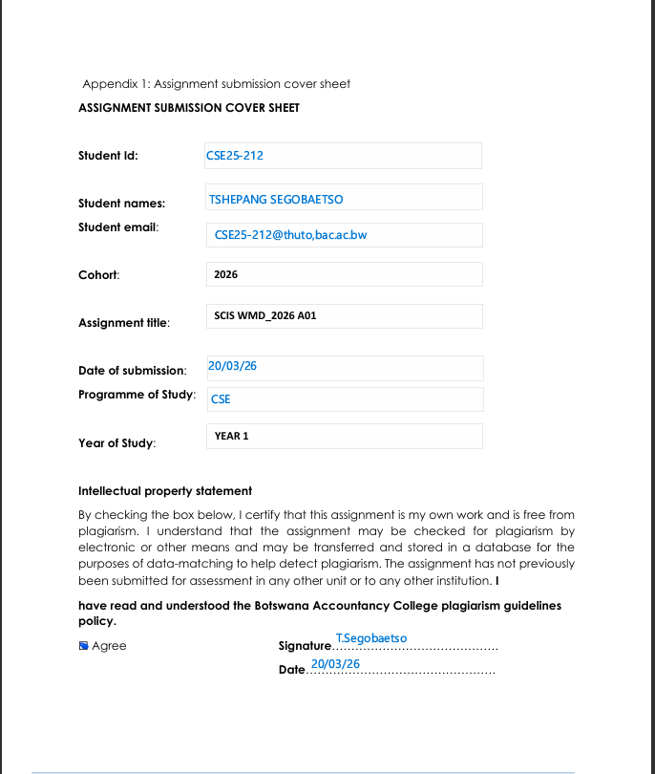

WEBSITE SPECIFICATION

a) State the website objective, its goals in relation to the businesses.
The objective of the redesigned Aptec Computers website is to create a more modernized and user-friendly online platform that shows computer devices, offers repair services and ensures improved customer engagement and satisfaction. The new design will focus on usability by making sure that it’s easy to navigate, fast loading time and clear content layout that will satisfy the user. It will also reduce clutter and make important information easy to find. In conclusion this redesigned website aims to improve functionality, usability, customer engagement compared to the existing version.
GOALS
- The main goal of the new model is to increase sales of computer devices and accessories
- To build trust and credibility through the newly developed website
- To provide clear information about the products and services which will help customers make their decisions easily
- To allow customers to contact or request services easily

b) State the target audience, showing their demographics and technical aptitude
DEMOGRAPHICS
The target demographics for this website includes:
-Age Group:18 – 50 years -small business owners
-Gender: Both male and female -Students:
-Location: People living in Cities and Towns in Botswana

TECHNICAL APTITUDE
Beginner/basic Users: This will include users who can do simple tasks like browsing the internet, looking for products and filling product forms. This will require the redesigned website that is easy to navigate and understand.
Intermediate Users: This are user who are familiar with technology and can compare products, understand each product specifications and able to make bookings for repairs and do some online inquiries about certain products.
Advanced Users: Some of users have higher technical understanding such as IT students and Professionals who really understand detailed computer specifications and services.
With all the above considered, the website should be user-friendly, simple, well organized, easy to navigate and most importantly it must be mobile friendly compared to the already existing one.

c)You must identify the type of website or content you will be designing for user
The website will continue to be used as a Business and E-commerce informational Website. The content of the website includes:
- Pricing of the computer devices and accessories
- Repair services information
- Product lists and specifications
- Contact and location
- Customer support information

Information design & taxonomy
INFORMATION DESIGN
The redesigned website will be able to represent content in a clear simple and user-friendly. Content will be neatly and well organized into section.
SITE MAP
HOMEPAGE PRODUCTS
-Welcome message -Laptops
-Featured products -Desktops
-Accessories
SERVICES ABOUT US
-Computer repair -Business background
-Software Installation -Mission & Vision
-Hardware upgrades
CONTACT US
-Phone number -Contact Form
-Email address

NAVIGATION STRUCTURE
HOME
ACCESORIES
DESKTOPS
LAPTOPS
CONTACTS
FEEDBACK
SERVICES
PRODUCTSS
ABOUT US

STORYBOARD IDEA
HOME
VIEW PRODUCT
SELECT CATEGORY
PRODUCTS

CONTACT OR BOOK
CHOOSE SERVICE
SERVICES
HOME
FILL FORM
CONTACT
HOME

HOMEPAGE WIREFRAME IMAGE DESIGN
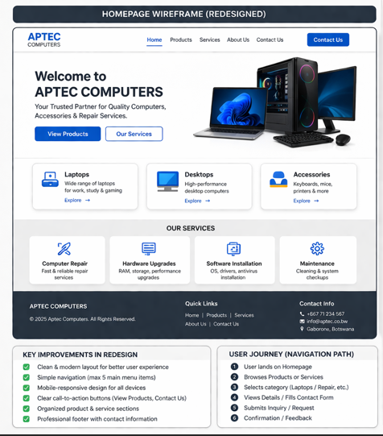
TECHNICAL BRIEF
Technologies to be used are:
HTML-For the structure of the website
CSS- For styling and layout
JavaScript- For doing menus, forms and validations
SOFTWARE TOOLS
Google Chrome -for testing and debugging
Photoshop or Canva- for graphics and images
VS Code/GitHub-for coding and editing
Adobe XD/Figma-For UI/UX design
The above tools are chosen because they are suitable for redesigning this website into a more modern and medium-complexity business website compared to the already existing one. All of the tools are easy to use and widely supported hence allowing a responsive design which will also be mobile friendly.

